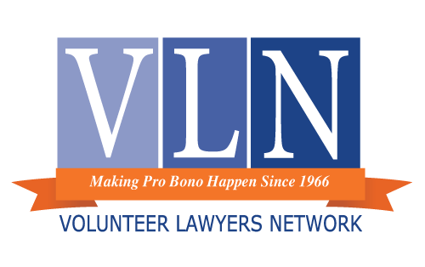
Volunteer Lawyers Network Conflict Waiver – Advice/Limited Services Only
As there are 2 or more defendants / plaintiffs (circle one) in this matter, there is a potential for a conflict of interest in Volunteer Lawyers Network’s legal advice. A conflict may arise whenever the interests of one client might affect, or be affected by, the interests of another client. When there are such multiple interests, there is always a possibility for the existence to interfere with the lawyer’s ability to serve one set of interests without adversely affecting other interests.
With respect to _____________________[case number], there exists the possibility for the following interests to become conflicting: _____________________________________________________________________________________
_____________________________________________________________________________________
_____________________________________________________________________________________
_____________________________________________________________________________________
Despite possibilities for such interests to conflict, you believe one lawyer can adequately represent, advance, or protect each such interest without harming any other such interests. Therefore, you agree that you want me to advise each of you in this matter and hereby waive the potential conflicts described.

We give our informed consent and waive any and all conflicts of interest to allow ____________
(attorney name) to advise both _________________________________________________ and
__________________________________ in this matter.

If during the course of our discussion any actual conflicts arise, the lawyer will immediately withdraw from giving any further advice to all parties.

_____________________________________________________________________________________
Client Signature Date:

_____________________________________________________________________________________
Additional Client Signature Date:

