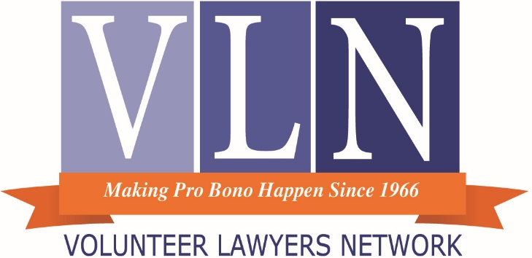
January 2017
Dear Colleague:
Thank you for your interest in promoting fairness and access to justice for everyone in our community.
You are among a privileged group of professionals who can provide access to the courts and protection of the laws, part of noble profession with a long history of protecting the defenseless. You can help clients obtain:
- Wages they have earned
- Security deposits to which they are entitled
- Legal garnishment exemptions
- Safe and habitable housing
- Lawful expungement of criminal records
- Access to family members
- Fair payment plans
- Bankruptcy relief
- And more
Otherwise, the legal remedies intended for all aren’t available to those in poverty and they often then go without basic life necessities.
We are ready to match you with clients whose issues fit your interests, as well as provide you with resources that can assist you in your valuable work. See the following pages for more information.
You will also reap benefits from volunteering, such as: learning new skills; networking with colleagues; learning from experienced mentors; making an impression with the local bench; malpractice coverage for VLN clients; administrative support; and knowing you have provided stability and justice to an individual in need. Our trainings will equip you to be a more informed community member and more able to connect with people who are different from you.
Thank you again for your time and interest in helping others. If any of us can ever be of any assistance to you, please do not hesitate to call me at 612-752-6671.
Sincerely,
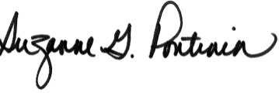
Suzanne Gautsch Pontinen
Executive Director

VOLUNTEER HANDBOOK TABLE OF CONTENTS

Welcome Letter from Executive Director 1
Staff Directory 4
About VLN 6
Mission and Vision 6
How VLN works 6
Holistic Services at VLN 7
Overall Supports for Volunteer Work 7
Volunteer Guiding Philosophy 9
Agreement between VLN and Volunteer Attorneys 11
What We Provide You 11
What We Ask of You 11
All Cases 11
Full Representation Services 12
Legal Clinics (walk-in) and Phone Services (by appointment) 12
Mentor Attorney 12
Mentee Attorney 13
Attorney/client relationships 13
Interpreters 13
Legal Clinic Assistants 13
Other Opportunities 14
Volunteer Resignation 14
Volunteer Termination 14
Recommended Case Handling Protocols 15
Preliminary matters in all levels of service: 15
Prior to providing brief services 16
Ongoing Case matters 17
Case conclusion 18
Other 18
Online resources for VLN Volunteers 19
VLN Website (www.vlnmn.org) 19
VLC Wiki (vlc.wikispaces.com) 19
Making a Difference for Your Clients from Poverty (wpbc.wikispaces.com) 20
Community Clinics Wiki (vlncc.wikispaces.com) 20
ProJusticeMN (www.projusticemn.org ) 21
LawHelp (www.lawhelpmn.org) 21
Resources to Help Serve Clients from Poverty 22
Breaking Poverty Barriers to Equal Justice Summary 22
Checklist Tool to Identify Poverty Barriers of a Specific Client 24
Claiming CLE Credit for Pro Bono 26
E-Filing and E-Serving 28
The Difference We Make 30
Bankruptcy 31
Consumer Debt 32
Conciliation Court 33
Letters to Creditors 34
Criminal Expungement 35
Family 36
Housing 37
Immigration 38
Spanish Legal Services 39
Administrative 40
Employment & UC 41
Real Estate 42
Tax 43

Additional Forms/Resources to be provided at CLE
- Representation agreement (green)
- Clinic Data Sheet (pink). This is the form attorneys complete at most clinics to report what services they provided the client.
- In Forma Pauperis instructions and forms. Most VLN full representation clients do not need to pay court filing fees (except for bankruptcy cases).
- MSBA Brochure “North Star Lawyer”
- Hennepin County Bar Association Flyer/Information
- Upcoming CLEs

Staff Directory
Agency Wide
Sue Pontinen, Executive Director sue@vlnmn.org
T: 612-752-6671
Tom Walsh, Deputy Director : tom@vlnmn.org
T: 612-752-6675
Nancy Johnson, Administrative Director nancyej@vlnmn.org
T: 612-752-6644
Martha Delaney, Education and Impact Director martha@vlnmn.org
T: 612-752-6676
Julie Thelen, Fundraising Coordinator julie@vlnmn.org
T: 612-752-646
Heidi Huber, Volunteer Coordinator and Database Manager: heidi@vlnmn.org
T: 612-752-6658
Emily Tanner, Administrative Coordinator emily@vlnmn.org
T: 612-752-6665

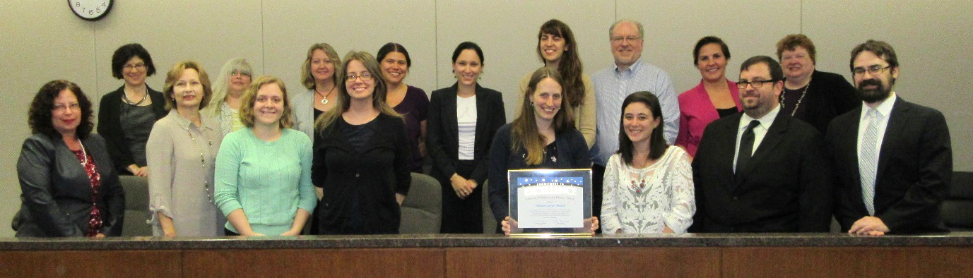
VLN Staff accepting the Fourth Judicial District Stephen Pihlaja Justice Partner Award

Bankruptcy Team
Tom Walsh, Resource/Managing Attorney tom@vlnmn.org
T: 612-752-6675
Chris Kramer, Judge Nancy C. Dreher Bankruptcy Fellow chris@vlnmn.org
T: 612-752-6645
Greg Rachwal, Case Coordinator greg@vlnmn.org
T: 612-752-6673

Civil, Employment, Letters to Creditors and Admin Law Team
Glen Drew, Resource/Managing Attorney glen@vlnmn.org
T: 612-752-6659
Emily Tanner, Case Coordinator Civil and Admin emily@vlnmn.org
T: 612-752-6674
Heidi Huber, Case Coordinator Employment, UC and Letters heidi@vlnmn.org
T: 612-752-6658
Criminal Expungement Team
Yaima Couso, Resource/Managing Attorney yaima@vlnmn.org
T: 612-752-6634
Vacant, Case Coordinator
T: 612-752-6635
Family Law Team
Kara Rieke, Resource/Managing Attorney kara@vlnmn.org
T: 612-752-6675
Greg Rachwal, Case Coordinator greg@vlnmn.org
T: 612-752-6673
Luce Guillen Givens, Case Coordinator SIJS Cases luce@vlnmn.org
T: 612-752-6667
Housing Law Team
Laura Busian, Resource/Managing Attorney laura@vlnmn.org
T: 612-752-6647
Vacant, Case Coordinator
T: 612-752-6635
Cassandra Phillips, Housing Law Pilot Project Manager Cassandra@vlnmn.org

Immigrant and Clinic Services Team
Colleen Beebe, Resource/Managing Attorney colleen@vlnmn.org
T: 612-752-6670
Barb Cruz, Coordinator barb@vlnmn.org
T: 612-752-6605
Intake Team
Claire Comstock-Gay, Intake Coordinator claire@vlnmn.org
T: 612-752-6657
Luce Guillen Givens, Intake Specialist luce@vlnmn.org
T: 612-752-6667
Dedicated Financial Coaching Line
Don Fulton, AFC®, CRC®, 612-752-6687

About VLN

Mission and Vision
VLN’s mission is to protect and promotes the basic needs of people in poverty through the power of legal volunteers. VLN envisions a society in which everyone has equal access to the legal services essential for stability and well-being.
VLN is one of the largest independent and oldest pro bono (volunteer-based) organizations in the country and recognized as a national leader in program development and best practices (including in innovative programming, collaborations with social services providers and outcomes measurement). VLN engages the vast resources of the private bar to help these people meet basic human needs, including sustenance, shelter, safety, and family relationships.
VLN staff members recruit and train volunteer attorneys, match client needs with appropriate legal specialties, and work strategically with like-minded community partners to craft innovative, cost-effective solutions to ongoing and emerging legal issues facing people living in poverty. VLN also works to increase awareness of the fact that everyone has legal rights, that remedies for injustice are available to everyone, and that VLN and other legal service organizations stand ready to help.
In 2015, more than 1000 dedicated volunteer attorneys provided 9,000 legal services, impacting more than 22,000 lives.
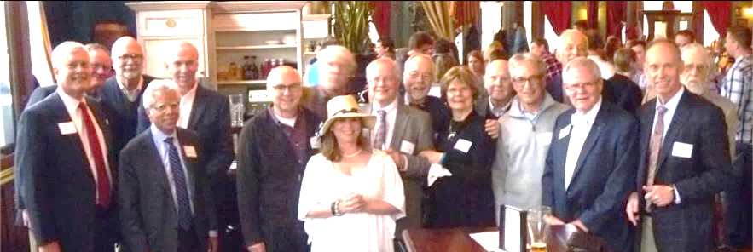

How VLN works
- Attorneys complete a registration form, including telling us in which areas of law they would like to help and what level of service (e.g., legal advice clinics, forms completion seminars, extended representation, mentoring, etc.) (www.vlnmn.org/volunteer-registration)
- We accept eligible clients for services through our Client Intake Line and various community clinics. (Eligibility depends on issue, income, and county.)
- We provide trainings to attorneys on various issues impacting people in poverty.
- We connect attorneys with individuals and families who need their help.
- We track services and outcomes to share with our stakeholders.

Holistic Services at VLN
VLN staff members are constantly striving to improve the impact of our work. This includes being as strategic as possible with the resources we have, so that we can ensure that everyone has access to the legal services necessary for stability and well-being.
Under our current strategic plan, our top goals are to:
- Deliver high quality legal services more effectively and to more people in need.
- Increase our financial and volunteer resources to address the critical needs in our community.
- Strengthen our organizational capacity to meet the challenges ahead.
One key initiative that fulfills all these goals is forming more collaborative partnerships so that our clients receive not only legal services but complementary social or other services as well. We have strong partnerships with many organizations in the community, including the Dignity Center, Pillsbury United Communities, and People Serving People.
We are also proud to have a staff with many diverse skills. Most recently, we have been lucky enough to have hired three staff members with some social services background, which helps them serve our clients and attorneys better.
Additionally, in April 2015, we formed a partnership with the Consumer Financial Protection Bureau (CFPB) and became an approved site for a CFPB trained financial coach. As a result, VLN volunteer attorneys have an additional resource to offer their VLN clients who would like help in establishing and meeting their financial goals. This is a free and confidential service complimenting VLN legal services. In the financial coaching process, the client decides what goals they want to set and why they are important to the client. The Financial Coach is a guide, resource, and accountability person in that process. For more information, direct VLN clients to call the Dedicated Financial Coaching Line at 612-752-6687.

Overall Supports for Volunteer Work

Below is a list of the ways in which we support VLN volunteer work. Each area of law has resources specific to their legal issues, which is provided in the areas of law section at the end of this packet.

- Client Screening: We offer you clients who have the legal issue in which you are interested in helping, as well as screening cases for merit and obtaining legally relevant information.
- Legal resources and trainings
  - Low-cost CLEs (https://www.vlnmn.org/events/)
  - Written resources many of which are online
    - https://vlc.wikispaces.com/ (password required)
    - www.lawhelpmn.org
  - Tips of the month: https://www.vlnmn.org/volunteer-resources/tip-of-the-month/
- Personalized coaching (applying what you’ve learned to the specific case situation)
  - Mentor attorneys
  - Resource attorneys
  - Procedures for shadowing experienced attorneys
- Resources on how poverty and race impact your pro bono representation
  - http://wpbc.wikispaces.com/
  - On-demand CLEs
  - Written resources
- CLE credit for pro bono (1.0 credit for 3.0 hours, up to six in a reporting period)
- Malpractice insurance (if you’re in our database and helping a client in our database)
- Interpreting assistance (contact Barb)
- Administrative support (conference rooms, help in obtaining IFP orders, etc.)
- Financial coaching assistance for your clients
- In select cases, case coordinator support for clients to follow your advice
- Partnerships with community agencies

Volunteer Guiding Philosophy
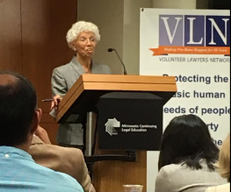
Volunteer Lawyers Network is based on the core founding principle that private attorneys must dedicate some time to representing clients in poverty because:
- Pro bono services increase overall access to the legal services necessary for stability and well-being in our communities.
- All attorneys, not just legal aid attorneys and public defenders, share the profound professional responsibility to ensure that the rule of law extends to everyone in our communities.
- Those in poverty, who otherwise may experience the law as arbitrary and predatory, have more experience of the law’s protections and fairness, leading to greater community-wide respect for the system and engagement.
- Lawyers who provide pro bono legal services benefit in that they:
  - Get the satisfaction of helping vulnerable individuals and families in our communities and directly contribute to their well-being.
  - Gain communication and other skills that improve their services to paying clients.
  - Participate in an enterprise which crosses over social barriers.
  - Connect on a human level with those who may be quite different from them, which may dispel stereotypes and increase curiosity and empathy.
  - Gain first-hand knowledge about the experience of those living in poverty and the resilience and resources of people who survive in poverty.
  - Contribute more knowledgeably to discussions about community-wide issues in various aspects of their lives.
  - Make more informed philanthropic and policy choices.
  - Promote a more efficient court system.

- The community as a whole is enriched as:
  - People form relationships across social barriers, is a necessary ingredient of any successful and positive social change.
  - More people of influence become advocates for those whom the legal system has otherwise not served.
  - More people are freed up to meet their human potential and participate more fully in our social and economic systems
  - Increased knowledge leads to policy decisions that are more effective in promoting safety, well-being and dignity for all.

To this end, Volunteer Lawyers Network serves the community by bringing private attorneys to meaningful pro bono work that is responsive to the needs in the community by:
- Designing programs that respond to the emerging and immediate needs of those in poverty.
- Leveraging attorney hours by screening clients for financial and merit eligibility, providing write-ups of their issue, providing case coordination assistance, and more.
- Educating attorneys about the laws that impact those living in poverty.
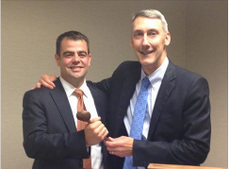
- Creating form templates, manuals, CLE resources and access to on-staff Resource/Managing Attorneys to help lawyers meet their professional responsibility to provide competent and diligent services.
- Having mentor attorneys on hand to answer specific legal questions from volunteer attorneys.
- Maintaining and providing expertise in various legal issues through on-staff Resource/Managing Attorneys.
- Providing attorneys with elimination of bias trainings essential to help them understand the barriers those in poverty face when trying to access the justice system, understand client behavior in the context of the poverty rather than that of middle class, increase the quality of services provided, increase client outcomes, and increase volunteer satisfaction.
- Providing structured and supported ways for attorneys to may meet their community leadership responsibilities of promoting justice and making justice equally accessible to all people.
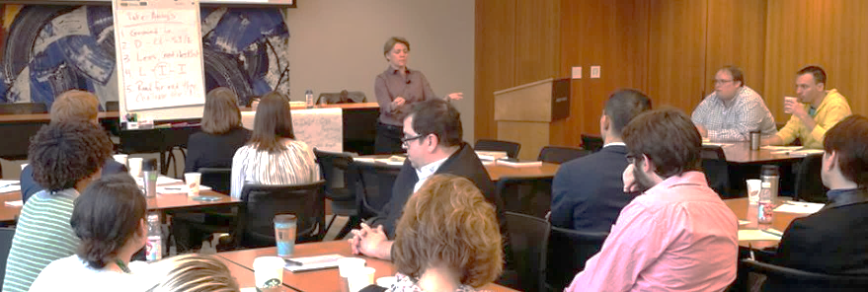
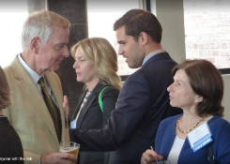
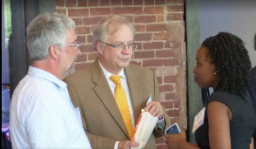

Agreement between VLN and Volunteer Attorneys
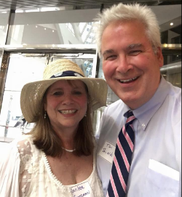
The below sets forth the fundamentals of the relationship between VLN and our volunteer attorneys, setting forth our various responsibilities. If you have any questions or concerns about the below, or think anything is missing, please contact us to discuss them.

What We Provide You
- Efficient and compassionate screening of clients for eligibility for your services.
- Keeping track of the areas in which you would like to volunteer
- Contacting you with opportunities to help clients in those areas (by phone or email).
- Malpractice insurance for any case that you receive through us.
- Free and reduced-cost CLEs on various substantive areas of poverty law
- Elimination of bias CLEs regarding working with clients of different races, income levels, ethnic backgrounds, mental health, etc., many of which are on-demand.
- Resources, forms, checklists and templates (many of which are available online at vlc.wikispaces.com and vlncommunityclinics.wikispaces.com).
- Resource and mentor attorneys.
- Volunteer librarian support.
- CLE credit for pro bono.
- Various forms of administrative support.

What We Ask of You

All Cases
- Be licensed to practice in Minnesota.
- Provide competent representation (Rule 1.1), including ensuring you have a basic understanding of the issues with which you will be helping your client, and a plan for how to get additional knowledge or assistance as needed.
- Provide your client with prompt and diligent representation (Rule 1.3).
- Communicate with your client effectively and in a timely manner (Rule 1.4), including keeping him or her informed about the status of the case, explaining the legal proceedings, helping the client understand his or her rights and options and discussing consequences of the legal actions your client may take.
- Maintain confidentiality (Rule 1.6).
- Comply with all other Minnesota Rules of Professional Conduct.
- Treat clients with the same professionalism and commitment as paying clients.
- Let us know if you are dissatisfied with our services to you or with your client. You can call our Executive Director, let us know in the case closing form, or complete our contact form on our website. (We have a grievance process when clients are dissatisfied.)
- To retain active volunteer status, help at least one client every two years (although we hope you will want to do much more than that!)

Full Representation Services
- Contact the client no later than within two weeks of accepting his or her case (unless the case requires immediate contact).
- Let us know if you have any problems contacting or communicating with your client or if your client becomes financially ineligible for your services.
- Sign our representation agreement with the client.
- Give us periodic updates on your case.
- Watch for other legal issues the client may have (and may not be aware of) and refer him or her back to VLN for help in addressing them.
- Complete the case, unless there are reasons to withdraw pursuant to the representation agreement.
- When the case is completed, fill out our online case closing form to let us know what work you did, what results you obtained, and any impacts on the client's life.

Legal Clinics (walk-in) and Phone Services (by appointment)
- Assess your client’s situation and provide him or her legal advice regarding his or her legal options and responsibilities. When there are no legal options, provide practical options.
- When your client does not have a reasonable chance of success in pursuing a claim, let him or her know (this can save him or her months of aggravation).
- Write down your instructions for your client to assist him or her in understanding, remembering and following them. (For phone services, consider emailing these to your client.)
- Give your client, when possible, applicable legal aid fact sheets (www.lawhelpmn.org).
- When possible, provide a brief service (such as making phone calls, writing letters, getting information from agencies, assisting in filling out forms, and other limited tasks). These can dramatically increase the impact of your help.
- Clinic only: Complete both sides of a Clinic Data Sheet for each client (and note if you will be helping the client beyond the clinic shift).
- Phone services only: Give VLN staff a brief summary of the nature of your advice.

Mentor Attorney
- Return phone calls to the mentee within a reasonable time and answer specific questions related to the client’s issue.
- Note: You are not required to give an overview of the law; the mentee is expected to do basic research and reading of the issue.

Mentee Attorney
- Do basic research and read the available VLN resources on the issue before contacting your mentor attorney.
- Ask case-specific questions of your mentor attorney.

Attorney/client relationships

In the process of routine intake of an individual’s legal matter (including helping the client to gather information and screening the case for merit), VLN does not form an attorney/client relationship with the prospective client.

VLN asks that all volunteer attorneys, pursuant to the Minnesota Rules of Professional Conduct, explicitly define the scope of their representation (and attorney/client relationships) as follows:
- At legal clinics, via the VLN Clinic Data Sheet
- For limited scope services, including by phone, via one of VLN’s Limited Scope Forms (Client Acknowledgement: What We Will Do To Help You Represent Yourself)
- For extended or full representation services, via a VLN Representation Agreement.
- For phone advice, via a statement at the beginning and end of the call to the effect of: The service I am providing you is limited to giving you advice while we are talking by phone. You are still responsible for xxx (specify any follow up actions needed).
In rare situations when a VLN Resource/Managing Attorney (RA) forms an attorney/client relationship with an individual by providing legal services, the RA will follow the above procedures. If, however, an RA’s phone advice will be followed by a volunteer attorney’s full representation services, the RA’s termination of the attorney/client relationship will be written as well as oral.

It is anticipated that client will never have concurrent attorney/client relationships with VLN and with a volunteer attorney.

Interpreters
Many of VLN’s clients speak a language other than English as their first language. This can make it particularly challenging for them to navigate the legal system and receives the laws’ protections. Whenever possible, through VLN’s Limited English Proficiency Policy, VLN provides legal services in the client’s language through an attorney who speaks their language (see, for example, Spanish Legal Services). However, when we do not have attorneys who speak a client’s language, we need volunteers who can interpret between the attorney and the client. Our greatest need for interpreters is currently Spanish and Somali. If you speak two or more languages, please ask for more information about VLN’s volunteer interpreter program by contacting the Spanish Legal Services program staff.

Legal Clinic Assistants
Legal clinic assistants can help lawyers in many ways, including
- Obtaining demographic information from clients
- Obtaining basic legal information from clients
- Helping organize a client’s paperwork
- Making phone calls on behalf of clients
- Drafting letters for attorney signature
- Obtaining court documents and more.
Clinics assistants include undergraduate students, law students, paralegals, law librarians, retired professionals, and more. In order to understand and implement clinic procedures, clinic assistants must commit to weekly two- to four-hour shifts. For more information, contact the program staff in the particular legal area of interest.

Other Opportunities
If you have a skill or interest that you think could benefit VLN clients or organizational effectiveness, please contact the deputy director of operations for more information.

Volunteer Resignation
A volunteer may resign at any time, while adhering to MNRPC regarding the effect on a client. VLN requests that a volunteer who resigns:
- Provide his or her reasons to the executive director or deputy director, in the event that the conditions which preceded the resignation might be addressed.
- Complete the representation of any VLN clients that he or she has undertaken.
Upon request, a volunteer will be “inactivated” in the VLN database so that he or she is not contacted by VLN staff unless requested by the volunteer at some future time.

Volunteer Termination
If the executive director has reason to believe that a volunteer attorney will not provide competent or appropriate representation to a client, the executive director may, at his or her discretion, instruct staff to not provide the volunteer with further volunteer opportunities.

Recommended Case Handling Protocols
To fulfill ethical requirements and best practices for avoiding malpractice claims, attorneys need systems for organizing the essential procedural parts of their services. While many different lists may be adequate, below is a list approved by VLN’s ethics advisor, Pat Burns (First Assistant Director, Office of Lawyers Professional Responsibility) and VLN’s malpractice carrier. It also incorporates some steps that can be helpful when representing clients from poverty.

Preliminary matters in all levels of service:
- Check for conflicts per the Minnesota Rules of Professional Conduct (MRPC).
- If a conflict is later discovered, appropriate consent (from the client and/or adverse party) should be obtained to provide representation despite the conflict or, if appropriate consent cannot be obtained, determine whether withdrawal is necessary.
- Ensure that the scope of representation is clear to the client by using one of VLN’s forms and including specific language regarding the legal issue that is the subject of the representation and what is NOT the subject of the representation. Include any limiting language (e.g., “writing letters to creditors to the following creditors: xxxx).
  - Full representation cases: signed retainer agreement
  - Workshop cases: signed brief services acknowledgement.
  - In-person legal services: signed clinic data sheet.
  - Phone advice: review the phone limited scope script with the client after providing legal advice: Before we hang up, I need to make sure you understand that I will not be able to provide you with any follow up service. You are still responsible for (specify any follow up actions recommended). Do you have any questions about that or anything else we discussed today?
  - Ensure that the party(ies) are clearly identified.
- In any service beyond legal advice alone, check to ensure that the client wishes to proceed with the service after you have informed him or her about the steps involved.
- If ongoing contact with the client is anticipated, establish up front numerous ways to contact the client and the consequences if the client is not able to be contacted.
- Create and maintain a comprehensive client list and tickle (reminder) system to ensure you meet all case deadlines, as well as have contact with the client at least once every 90 days.
- Review the VLN attorney/client understanding, including establishing expectations with the client regarding:
  - when and why you will be in touch
  - when and why you expect him or her to be in touch
  - how often he or she can expect updates from you
  - how often/when you would like updates from the client
  - whether the client prefers that you mail him or her copies of all correspondence and court documents immediately or hold them for the next time you see each other

Prior to providing brief services
Limited scope legal services for pro bono clients, including making a phone call, drafting a pleading, or writing a letter, provide access to justice to many struggling families and individuals in our community. Studies show that limited scope services can, with a limited amount of attorney time, provide clients with concrete outcomes to their legal matters. However, limited scope services are not right for every situation. Below is a checklist to ensure that a given limited scope service complies with the MRPC and can genuinely advance the client’s case.
- Keep an eye out for conflicts. The standard for pro bono limited scope services is “actual knowledge.” (Rule 6.5. This applies to pro bono representation only.) If you know that you or someone in your firm represents the client’s adverse party, do not give any legal advice to the client.
- Assess the extent to which the client’s issue is both legal and has merit (Rule 3.1). If not, consider other alternatives for problem solving, including moral, economic, and social factors that may be relevant to the client’s situation (Rule 2.1). Consider litigation alternatives (neighborhood dispute resolution resources, mediation, informal requests for relief, etc.), if appropriate and likely to assist the client. If the client simply does not have a legitimate grievance or is unlikely to obtain any relief, you should be clear in advising the client that there is no merit to their position and you will not be assisting them.
- Communicate clearly to the client about the scope of your representation. Note: per Rule 1.2(c): A lawyer may limit the scope of representation if the limitation is reasonable under the circumstances and the client gives informed consent. If it is reasonably foreseeable that the person receiving the advice will rely on the advice, an attorney-client relationship is formed. Pine Island Farmers Coop v. Erstad & Riemer, 694 N.W.2d 444, 448 (Minn. 2002), Togstad v. Vesely, Otto, Miller & Keefe, 291 N.W.2d 686, 693 (Minn. 1980). When limiting the scope of representation, specify:
  - What services you will provide
  - What services you will not provide (Rule 1.2)
  - What the client must accomplish on their own in order to achieve objectives.
At VLN clinics, (a) and (b) are handled in the Client Acknowledgement on the Clinic Data Sheet, although it may be necessary to also orally tell the client that you will not be representing them in court or help them on an ongoing basis. (C) is best provided on the Attorney Suggestion Form.
- Evaluate whether the circumstances for unbundled services are reasonable under the circumstances (Rule 1.2), including the following criteria:
- Whether the client will be better off with limited services than without.
- The nature of the matter in substantive law and complexity. Cases with a high level of complexity are probably inappropriate for limited scope services. Per Rule 1.2, Comment [2]: If a short-term limited representation would not be reasonable under the circumstances, the lawyer may offer advice to the client but must also advise the client of the need for further assistance of counsel. See also Rule 6.5.
- The sophistication and abilities of the client to continue pro se. For example, assess whether the client can understand what is being asked for in the pleading, whether the client could represent herself at a hearing on this matter and answer questions stemming from the pleading. The client does not need to have the same depth of understanding as a lawyer might, but should be able to understand and articulate the basic arguments.
- Whether there is sufficient time to complete the brief services contemplated.
- Ensure pleadings are brought in good faith, and have reasonable basis in both law and facts (Rules 3.1, 3.3, and 11.02). The obligation to the client and the court to investigate whether the pleadings are well founded in law and facts requires a reasonable inquiry under the circumstances and is not substantially less than in full representation. One practical suggestion to prevent frivolous claims is to discuss potential allegations and counsel the client to not sign the pleadings until and unless he or she can gather more factual support for a particular allegation.
- If at LAP, use the “Assisted at VLN’s Legal Access Point Clinic” stamp on each pleading. This gives transparency to the court about the circumstances of the drafting of the pleading, addressing potential concerns about ghostwriting.
- Keep a copy of what you have done. At the Legal Access Point (LAP) clinic, for example, ask a clinic assistant to scan a hard copy and/or save electronic copy on the VLN flashdrive.
- Maintain client confidentiality. Your obligation in limited scope services is the same as required in more traditional attorney-client relationships (Rule 1.6)
- Additional considerations may apply to immigration cases.

Ongoing Case matters
- Determine whether there are any issues directly related to their legal issue and provide the client with advice, guidance and/or referral for those issues.
- Review and send a case acceptance letter, including consequences if the client can’t be located at a future date
- Create a case file and keep a copy of all documents, including:
  - The retainers
  - The VLN attorney client agreement
  - The case acceptance letter
  - Copies (not originals) of any paperwork the client provides
  - Copies of any other paperwork relevant to the case
  - Copies of any letters sent on behalf of or to the client
  - Copies of any paperwork served on other parties
  - Copies of any paperwork filed with the court or received from the court
- Include notes of all work done on the case (and next steps to be done).
- Return client calls promptly
- Meet all court and other deadlines
- Immediately notify clients of all settlement offers
- Provide clients with timely, adequate notice of pending court appearances, meetings and/or depositions, as well as the consequences if he or she misses them
- Follow the expectations you set in the initial meeting
- When needed, consult with other attorneys regarding areas of law you may not know, collateral consequences of any settlement agreements, etc.
- Take steps to ensure that disclosure of confidential information does not take place in the presence of non-clients. In the alternative, ensure that the clients are warned of potential waiver of privilege or take other steps to protect confidentiality.

Case conclusion
- When a full representation case is concluded (either by resolution of the matter or by withdrawal), let the client know that both orally and in writing. See VLN’s sample closing letter, attached. The letter should include:
  - That the legal proceedings are concluded or, if they are not concluded, the stage of the legal proceedings, any next steps the client should take, and all upcoming deadlines (and consequences of missing them).
  - Any helpful referral sources
  - A link to the VLN client survey
  - A list of any documents that are being returned.

Other
Included in general supervision duties, all attorneys are ethically required to ensure that support staff are complying with the Rules of Professional Responsibility, including:
- Not engaging in the unauthorized practice of law by giving legal advice to others.
- Complying with the MRPC sections on conflicts.
- Ensuring that confidentiality is maintained.

Online resources for VLN Volunteers

VLN Website (www.vlnmn.org)
Includes information about how to volunteer, volunteer resources, events, how individuals can apply for help from VLN, and more

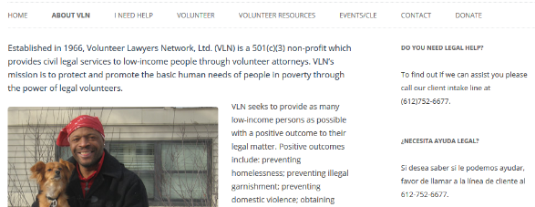

VLC Wiki (vlc.wikispaces.com)
Houses VLN-created or recommended resources for full rep cases. Access by setting up a wikispaces account and then clicking “Join” the VLC wiki.
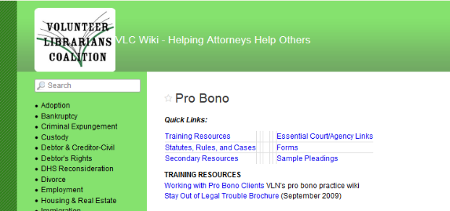
Click on the menu item on the left to get our helpful in-house resources.

Making a Difference for Your Clients from Poverty (wpbc.wikispaces.com)
Suggestions for working with clients from generational poverty. Open access.

Community Clinics Wiki (vlncc.wikispaces.com)
Houses VLN-created or recommended resources for legal advice clinics. Open access.

ProJusticeMN (www.projusticemn.org )
Houses resources for pro bon attorneys statewide. Apply for membership, approval within 24 hours. Excellent resource to join. VLN houses many past webinars in the Library.
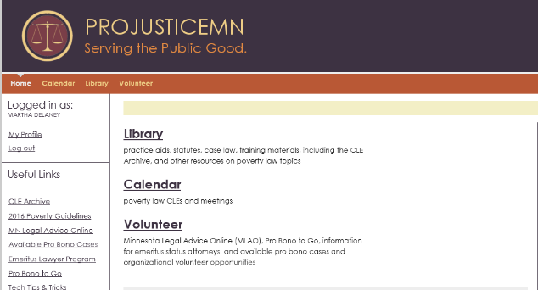

LawHelp (www.lawhelpmn.org)
Legal information for laypeople. Open access. Excellent info to give to clients (as well as to review on own).
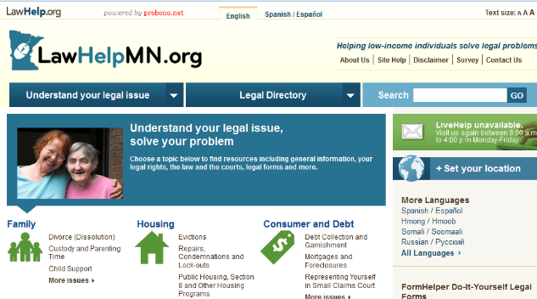

Resources to Help Serve Clients from Poverty

Breaking Poverty Barriers to Equal Justice Summary
- Watch for judgment; it prevents connection and communication. Understanding that it’s human to judge when we see differences, be diligent about looking for cues of bias, such as frustration or other internal feelings of discomfort around differences. Unless we see this, we’ll lose our ability to help someone different from us.
- To overcome judgment, become curious and seek more information. While many attorneys have had experiences of “situational” poverty (or see how poverty is misportrayed in the media), many pro bono clients come from “generational,” “working class” or “immigrant” poverty, with very different experiences and skills. Learn about the context of poverty to help understand your client’s decisions, common logistical barriers to participating in legal processes, and ways he might communicate and organize organization differently. Unless we understand the context, we may make faulty assumptions about motives and be less wholehearted in our efforts.
- Build trust. Be friendly and make sure your body language and nonverbal communication support your words as you start to get to know each other. Identify and share some things you might have in common. Do you both have children a certain age, have a pet, enjoy a certain sport?
- Build in a little extra time for meetings. People in poverty may be late to meetings based on unexpected crises or lack of familiarity with the meeting place. Consider unilaterally giving your client a 15-20 minute grace period, as well as sending reminder emails or texts. It can also support trust and focus to let him know up front how much time you have for the meeting and provide an agenda of what you need to cover.
- Determine the specific circumstances of your client’s life that may impact the ability to participate in the legal process. To identify any logistical barriers, have a checklist of questions to ask, including numerous contact information, job hours, transportation issues, day care, etc. (See sample Attorney Client Understanding.)
- In communications, ensure you are understanding your client. For example:
  - Use common active listening techniques, such as repeating back every so often what you hear to make sure you are understanding it correctly.
  - If a client is sharing information in a way that is more circular than linear, feel free to interrupt after a while to gently guide the conversation back. (The meeting agenda can help too.) But in the meantime, listening to the story can help you identify more ways to build identification with him.
  - Ask open-ended questions and try to stay away from questions that ask “why,” which can put people on the defense. Instead, use statements such as, “Help me understand,” or “Tell me a little more about...” If a question seems invasive, preface it by letting your client know why you are asking it.
  - When determining the facts of the case, you might first put your pen down and ask your client to tell you what happened. (This also supports trust.) Next, ask
her to repeat the story, while you take notes, Finally, repeat back the story to see if you have understood. (Even your notes were accurate and complete, you may find out additional information in this third step.)
- Ensure your client is understanding you. For example:
  - Use visuals as much as possible (including drawing out next steps).
  - Make sure your body language supports your verbal communication.
  - Use stories as a way to explain (“Here is what worked for my client Julie.”).
  - Summarize every so often.
  - Ask her to summarize. “I’d like to make sure I’m being clear. Could you tell me what you are understanding the next steps are?”
  - Use familiar words and examples that laypeople can relate to.
  - Use a variety of examples to convey difficult points (trying to draw from the context of poverty rather than that of middle class).
  - Minimize the chance of losing your client through legalese, e.g., “I’m used to being around lawyers all day and can sometimes forget how to talk in plain English. If I slip up and use words you’re not sure about, please let me know.” (This phrasing owns our responsibility as the professional to be clear, rather than asking clients to let us know if “they don’t understand.”)
  - Review written communication orally and use a third grade level and clearly organized bullet points and graphs (whether or not your client is literate).
- Customize your services to what the client wants. One solution does not fit everyone. Make sure you ask for your client’s goal after you have provided your assessment of the case and the available options. Understand that she may not want to pursue legal action. (For example, if it’s going to take five months to get the security deposit back, the case may take a lower priority in her life given other crises going on.)
- Be aware of the power differential. Many pro bono clients feel intimidated or shame around lawyers. Pay attention to ways in which you can make her feel more comfortable (such as sitting at a conference table rather than an imposing desk).
- Consider the difference between empowerment and overwhelm. Clients whose basic needs are not met are not in a position to be empowered. For others, teaching them how to do things for themselves is a deep service. It’s critical to know the difference.
- When giving instructions, give context (explain why), break them down into manageable steps, and ask whether the client is able to do them. Because it’s second nature for us to schedule and keep appointments, keep a calendar, plan for future events, and organize paperwork, it’s hard not to assume that everyone has those skills. However, the skills it takes to succeed in middle class or wealth are quite different from the skills it takes to survive in poverty. Find out whether your client has the ability to follow the instructions, given skills and other things happening in his or her life. If appropriate, offer supports.

The Breaking Poverty Barriers to Equal Justice curriculum is a nationwide resource created by:

Checklist Tool to Identify Poverty Barriers of a Specific Client
Attorneys: Please review this verbally with your client at the initial meeting, allowing time for questions and clear understanding. A written copy should also be provided.
You have qualified for free legal services through VLN. I am a volunteer attorney for VLN and I will not charge you fees for my legal services. I have a license to practice law in Minnesota.
I will be diligent in protecting your legal rights and achieving the goals we set for your case.
So you can make informed choices, I will explain the law, your rights, your responsibilities, your legal options, your other options, how those options might play out, and my recommendations.
If your case might require you to pay fees to the court or another agency, I will let you know in advance and discuss your options.
I will let you know of any updates to your case, including any settlement offers.
What you share with me about your case is confidential, per the Rules of Professional Conduct.
I will try to work around what is going on in your life when setting up meetings. Please note, however, that the courts are open only during normal business hours.
I will review with you a separate written agreement naming the issue I’m helping you with and telling you what I will do for you. I will answer any questions you have about this agreement, including reasons that would require any lawyer to stop representing someone.
These types of cases typically take __________________________, but your case may take longer or shorter depending on various circumstances, some of which are out of our control.
If I can’t help you with something, I will do my best to connect you with someone who can.
Please note that no lawyer can guarantee that you’ll win or meet your goals.

It will help me represent you if you could . . . .
Overall
Tell me what you want to happen in your life related to your legal issue. If I know your goals, I can help you better.
Share all the facts with me - even facts that you think might be unimportant or may make you look bad. If you don’t, the advice I give you and my plan to help you might not be best for your situation. It can make things a lot worse if the judge or others involved in the case find out facts that I don’t know about.
If my recommended plan for meeting your goals seems like more than you can or want to do, please let me know. We can look at other options. Sometimes, the legal system can result in more work than benefits, and problems may be best solved in other ways.
Before you see me, think of questions you might have for me. Some people find it’s helpful to write down questions ahead of time.
Let me know if you have a hard time getting the paperwork I need for your case. If that happens, I will try to help or find others who can. I’ll attach a list of some of the paperwork I will need and where you can get it. You may mail it to me or fax it to me (see my business card).
Let me know if other legal issues come up as they may change how we work on this case. I will look for someone who can help you with the other legal issue(s), including VLN.
If I am ever not being clear, please ask me to explain it again or in another way. I also will write down my advice or instructions so you can look it over later or with a friend.
Please tell me: Are there any physical or mental disabilities you would like me to know about that may impact our work together? Are there any other legal or personal problems you’d like me to know about that may impact our work together?
Scheduling meetings
Please tell me: What hours do you work? Can you get time off during those hours? Do you have childcare? If yes, how would that impact your availability for meetings? Would it be difficult to get to my office by car or bus? Would there be a more convenient public location to meet? Is there anything else you’d like me to know about that will impact your ability to meet with me or attend a court hearing?
Please do your best to arrive on time to our scheduled meetings. If you will be late, please call me at ______________________. If you will be more than ____ minutes late, and I have another meeting scheduled after yours, I may need to reschedule our meeting to another day, to make sure we have enough time together.
If something comes up and you are unable to make a scheduled meeting at all, please call me as soon as you know so we may reschedule.
Staying in touch with each other
Please tell me: what are the best ways to reach you (such as phone, address, and email)? How would you prefer that I contact you? What are some alternate ways to reach you? What are some contingency ways to reach you (such as family or friends)? What are some emergency ways to reach you? Do you have easy access to a free fax machine? Do you have easy access to an email? (The more information I have, the more likely we’ll be able to stay in touch).
If these change, please give me new information right away. The law might require me to notify others of any address/phone number changes within as little as five days.
If something happens in your case, such as: ______________________________________ _____________________________________________________________________________________________________________________________________, call or write me per my business card (You may want to put my card in your wallet and phone so you have it with you.)
When I contact you, please get back to me as quickly as you can. Legal issues can move fast and I may need a decision from you.
I will return your phone calls as soon as I can. (If your call is urgent, please let me know.) If ____ days pass and I haven’t returned your call, please call back again.

Claiming CLE Credit for Pro Bono

Attorneys volunteering through VLN may report one CLE credit for every six hours of pro bono work through VLN. This includes, for example, volunteering on full representation cases, at clinics, and/or to mentor another VLN volunteer. For every three-year reporting cycle, attorneys volunteering through VLN can claim up to six credits this way.
To claim these credits, follow two steps:
- Record your hours with VLN.
  - Check that your client came from a VLN staff person or VLN-clinic.
  - Report your pro bono hours to VLN:
    - If a full representation case, on the case closing form here.
    - If a clinic case, complete the on-site clinic data sheet, including time spent with the client.
- Apply for the CLE credit at the Minnesota State Board of Continuing Legal Education site. By completing the form on the reverse, scanning it, and emailing it to attendance@mbcle.state.mn.us.
Note: if you volunteer at a VLN clinic in partnership with your law firm: you may also be able to list your firm and pro bono coordinator as the “legal services provider”

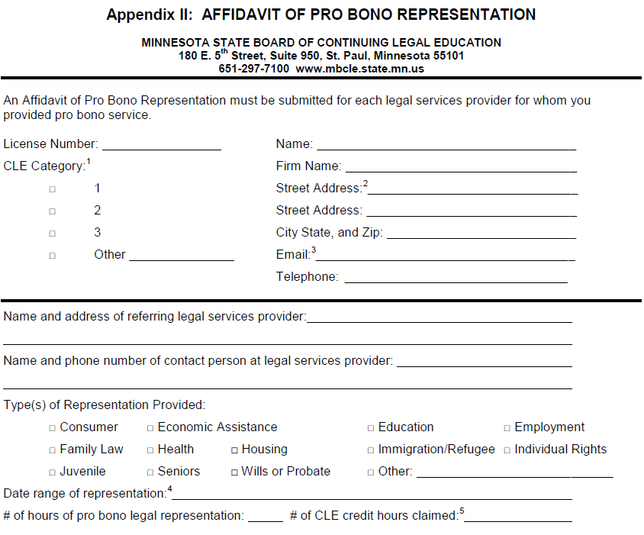
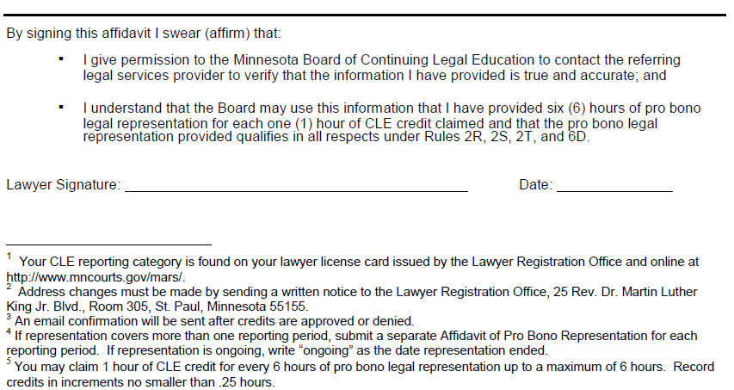

E-Filing and E-Serving

Starting September 1st 2012, e-Filing is mandatory for many types of general civil cases in the Second and Fourth Judicial Districts. E-Filing is the filing of court documents through a computer based system. The system used in the Second and Fourth Judicial Districts is called Odyssey File & Serve (OFS). Attorney and government agencies must be registered in order to use the e-Filing system by the effective date. Volunteer attorneys working on housing or family cases will be required to e-File and e-Serve cases starting on this date. At this time, pro se parties will not be required to use the e-Filing system.
Before e-Filing and e-Serving, all attorneys are encouraged to complete training offered by court administration. At trainings, information will be provided regarding how to register for and use the OFS system. The Courts’ website lists available in-person and online trainings.

Below is information about how the changes will affect attorneys representing VLN clients.

Access and Registration
- In order to register for an account, see each district’s website. You will find information regarding trainings, registration, and frequently asked questions.
- Direct questions about registration to the courts.
- Each VLN volunteer will need to register through his or her firm or individually, but not through VLN. Each firm needs a firm administrator, who will be responsible for creating and managing the firm’s account. The firm administrator should attend e-File training with court administration. Once the firm administrator attends the training, he or she should go to the OFS website and select “register now” to begin the registration process.
- In the OFS system, VLN clients should be treated the same as an attorney’s personal clients. VLN is not the firm for each volunteer when they are e-Filing a case on behalf of a VLN client. While VLN will have its own account, is solely for VLN staff attorneys.
Quick Notes
- The OFS system is not a case management system. It is the system that will be used by the Second and Fourth judicial districts to process court filings and service. For example, documents will only be viewable on OFS for 30 days. Attorneys should continue to maintain their own case management files.
- Any document that is submitted through the OFS system will be reviewed by court administration before being forwarded to the assigned judicial officer. This process can take up to one business day. If there is an error in filing, such as filing the documents in the wrong case, not paying the filing fee, or filing in the wrong county or division, it will be rejected. For information regarding rejected filings, see the Courts’ website.
- The Minnesota Rules of Civil Procedure and Minnesota General Rules of Practice have been amended to include e-File rules. A copy of the amended rules can be found at:
http://www.mncourts.gov/Documents/0/Public/Clerks_Office/ADM108011-05242012.pdf

Service
- E-Service will not replace personal service. The initial filing of the complaint will still need to be done via personal service. E-Service is to replace service by mail and facsimile on represented parties. See amended Rule of Civil Procedure Rule 5.02 (b).
- E-Filing and e-Serving a document will not require an affidavit of service. The record of e-Service on the system shall constitute proof of service. See the Amendments to Minnesota General Rules of Practice Rule 7.
Fees
- Fee waivers are still available for e-Filing documents.
  - In the Fourth Judicial District, you must obtain an IFP order signed by the appropriate signing judge for civil and family cases, or by the housing referee or clerk for housing cases. You must then scan the IFP order, upload it to OFS, and submit it with your filing.
  - In the Second Judicial District submit the IFP and proposed order with your filing through OFS. The court staff will present the IFP to a judicial officer for approval. If the IFP has been denied, the court staff will notify you.
- As a volunteer attorney representing a VLN client, you will not need to use a credit card. Because you are representing the client on behalf of VLN, a volunteer attorney program based upon indigency, the client will likely qualify for a fee waiver. When OFS prompts you for payment, select the waiver account option, and submit the IFP order.
- There are extra fees associated with e-Filing and e-Serving. Tyler Technologies, the provider of the OFS system, automatically assesses a $5 credit card convenience fee and a $3 e-Service fee. The $5 credit card convenience fee is only charged for documents that have a statutorily required filing fee. The $3 e-Service fee is charged anytime the e-Service function is used. A signed IFP order will waive these costs.
- Address any questions regarding fees and fee waivers to court administration in the judicial district where you will be filing.

The Difference We Make

Annually, we protect or recover a combined total of more than $4-5 million of our clients’ scarce resources - through bankruptcy discharges, establishment of child support, garnishment prevention, judgment prevention, etc. Given that keeping cash in the homes of struggling families is an effective anti-poverty tool, we are having a profound impact on the families in our community.
Furthermore, regardless of any monies protected or recovered, in 80-90% of applicable cases, we can tell our funders that client’s life was tangibly improved as a result of our legal work, including improved housing, improved ability to find or keep a job, better quality of life, etc.
How do we know this? Because we ask all attorneys and clients to tell us about the services completed and results obtained. This ensures we can show our relevance to funders and the larger community, which is essential to our continued funding and effectiveness.
Full representation services: This includes completing our online case closing form (takes about ten minutes, which you can include in your pro bono hours) at www.formstack.com/forms/vln-closing.
- Please complete the form in order of questions asked. The fields that appear are determined by your answers to preceding fields. For example, the type of case you select will bring up a field with results specific to that case
- Please answer all questions to the best of your ability. All questions are required by funders (such as whether a veteran resides in the household) or help us meet best practices in program administration (such as asking for the client’s up-to-date contact information).
- When answering the outcome questions, there may be questions you aren’t sure how to answer. In those cases, please use the “more likely than not” standard so we are consistent with other programs across the state.
Phone services: Please provide a summary of your advice or brief services, as well as any follow up actions you think would be helpful to the client. If you are screening a case for merit, please provide clear instructions as to what services you think the client should receive and why.
Legal clinic services: On the VLN Clinic Data Sheet, please check the box next to the service you provided, as well as any details regarding any follow up service you may be providing.

Bankruptcy | Give individuals and families a fresh start, so they can better pay for their daily necessities, stop garnishments, secure drivers’ licenses, and/or pay their utilities.

Full representation services¹ GREAT NEED
- Chapter 7 bankruptcy
- Bankruptcy adversary proceedings
- Note: attorneys must be licensed in federal court. VLN can assist with the process.

Phone services² NEED
- Advice regarding discharging debt through a chapter 7 bankruptcy
- Advice regarding stopping creditor harassment under Fair Debt Collection Protection Act
- Determining whether clients meet VLN criteria for full representation in chapter 7 bankruptcy or, in the alternative, “stop contact” letters to creditors.

In Person Legal Clinic Two-Hour Shifts² NEED
- Advice and, when appropriate, brief legal services⁴ regarding any bankruptcy issue
  - Bankruptcy Court Clinic, Federal Courthouse in Minneapolis
  - Bankruptcy Court Clinic, Federal Courthouse in St. Paul

Mentor Attorney³ NEED
- Spend two to eight hours answering case-specific questions from an attorney new to the area of law.

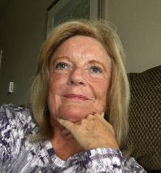
Resources Available
- Petition-preparing software
- Mentoring from experienced attorneys

Contacts
- Resource/Managing Attorney: Tom Walsh
- Case Coordinator: Greg Rachwal

Consumer Debt | Ensure individuals and families receive the laws’ protections so they can meet their basic daily needs.

Full Representation Services¹ NEED
- Answering debt collection lawsuits
- Defense in uninsured motorist accidents
- Claiming exemptions in response to levy or garnishment

Phone services² FILLED
- Advice and, when appropriate, brief legal services⁴ regarding Civil debt collection issues
- Brief legal services (drafting answers, interrogatories, request for production, request for admissions, bank account garnishment exemption claims)
- Determining whether clients meet VLN criteria for full representation services

In Person Legal Clinic Two-Hour Shifts² GREAT NEED
- Legal advice and court document drafting - answers, interrogatories, request for production, request for admissions, bank account garnishment exemption claims
  - Consumer Protection Workshop, Minneapolis
- Legal advice and, when appropriate, brief legal services⁴ on various district court issues.
  - Legal Access Point clinic, Hennepin County Government Center

Mentor Attorney³ NEED
- Spend two to eight hours answering case-specific questions from an attorney new to the area of law.

Resources Available
- Forms & templates
- Mentoring from experienced attorneys

Contacts
- Resource/Managing Attorney: Glen Drew
- Case Coordinator: Emily Tanner

Conciliation Court | Help individuals and families bring claims in small claims court.

Full Representation Services¹ NEED
- Collecting on existing judgment against landlord or employer
- Conciliation court appeals

Screening for Merit² NEED
- Determining whether clients meet VLN criteria for full representation services

In Person Legal Clinic Two-Hour Shifts² GREAT NEED
- Legal advice and, when appropriate, brief legal services,⁴ regarding small claims court issues
  - Conciliation Court Clinic, Minneapolis
- Legal advice and, when appropriate, brief legal services,⁴ regarding small claims appeals
  - Conciliation Court Appeals Clinic, Minneapolis

Mentor Attorney³ NEED
- Spend two to eight hours answering case-specific questions from an attorney new to the area of law.

Resources Available
- Forms & templates
- Mentoring from experienced attorneys

Contacts
- Resource/Managing Attorney: Glen Drew
Case Coordinator: Emily Tanner

Letters to Creditors | Give people relief from relentless creditor harassment, including illegal abusive calls at all hours, so they can live their lives in peace.

Full Representation Services¹ NEED
- Writing “stop contact” letters to a client’s debt collectors under the Fair Debt Collection Practices Act, requiring them to stop contacting the client directly. Includes follow-up creditor correspondence for a minimum of 6 months.

Limited Scope Representation¹ LOW NEED
- Writing “stop contact” letters to a client’s debt collectors under the Fair Debt Collection Practices Act, requiring them to stop contacting the client directly, with limited follow-up

Mentor Attorney² FILLED
- Spend two to eight hours answering case-specific questions from an attorney new to the area of law.

Resources Available
- Forms & templates
- CLE materials
- Mentoring from experienced attorneys

Contacts
- Resource/Managing Attorney: Glen Drew
- Case Coordinator: Heidi Huber

Criminal Expungement | Provide people who can show they’ve rehabilitated access to a fresh start, so they can secure jobs and housing.

Full Representation Services¹ GREAT NEED
- Expungement of Minnesota criminal records
- Note: This is a civil area of law; volunteers do not need to know criminal law.

Phone services¹ NEED
- Advice and, when appropriate, brief legal services⁴ regarding criminal expungement issues
- Determining whether clients meet VLN criteria for full representation services.

Screening for Merit² GREAT NEED
- Attending educational presentations around the Twin Cities metro area and providing legal advice and referrals to seminar participants
- Determining whether clients meet VLN criteria for full representation services

In Person Legal Clinic Shifts¹ GREAT NEED
- Advice and, when appropriate, brief legal services⁴ regarding criminal expungement issues
- Second Chance Saturdays (Minneapolis)
- Ramsey County Criminal Expungement Courthouse Clinics

Resources Available
- Hot Docs & petition-preparing software
- Forms & templates
- Mentoring from experienced attorneys

Contacts
- Resource/Managing Attorney: Yaima Couso
- Case Coordinator: TBD

Family | Support parent-child relationships, improve safety and financial security, and improve quality of life.

Full representation services¹ GREAT NEED
- Divorce
- Custody and third party custody
- Special Immigrant Juvenile Status (SIJS)
- Adoption

Phone services² NEED
- Advice and, when appropriate, brief legal service^{s4} regarding family and juvenile law issues

Screening for Merit³ GREAT NEED
- Determining whether clients meet VLN criteria for full representation services

Other limited scope representation² NEED
- Representation for a specific issue or hearing in a family law issue
- Drafting pleadings or assisting with filling out court forms for child support or parenting time cases
- Trial and pre-trial prep

In Person Legal Clinic Two-Hour Shifts² GREAT NEED
- Advice and, when appropriate, brief legal services⁴ regarding any family court issue
  - Family Law Clinic, Family Justice Center, Minneapolis

Mentor Attorney³ NEED
- Spend two to eight hours answering case-specific questions from an attorney new to the area of law.

Resources Available
- Forms & templates
- Mentoring from experienced attorneys

Contacts
- Resource/Managing Attorney: Kara Rieke
- Case Coordinator: Greg Rachwal
Housing | Prevent homelessness, improve housing conditions, improve children’s educational stability, and keep a family safe.

Full representation services¹ NEED
- Eviction actions (unlawful detainer) and eviction expungements
- Repair problems and habitability issues
- Current landlord demanding payment of rent owed
- Landlord harassment
- Section 8 or public housing terminations
- Lockouts and utility shut-offs

Phone services¹ NEED
- Advice and, when appropriate, brief legal services⁴ regarding any of the above issues

In Person Legal Clinic Shifts¹ NEED
- Advice and, when appropriate, brief legal services⁴ regarding any housing law issues
  - Housing Court Project, Hennepin County Government Center, Minneapolis

Mentor Attorney³ NEED
- Spend two to eight hours answering case-specific questions from an attorney new to the area of law.

Resources Available
- Substantive and procedural resources
- Forms & templates
- Mentoring from experienced attorneys

Contacts
- Resource/Attorney: Laura Busian
- Case Coordinator: Cassandra Phillips

Immigration | Help people who have recently immigrated to the United States obtain legal status and safety.

Full representation services³ NEED
- U-Visas
- DACA
- Other miscellaneous immigration matters where special circumstances are involved

Phone services³ NEED
- Advice and brief services⁴ regarding various immigration issues
- Determining whether clients meet VLN criteria for full representation

In Person Legal Clinic Two-Hour Shifts³ GREAT NEED
- Legal advice and, when appropriate, brief legal services⁴ regarding various immigration issues
  - Park Ave Methodist Clinic (Minneapolis)
  - Family Unity Project (Minneapolis & St Paul)
  - Brooklyn Legal Clinic (Brooklyn Center)
  - Waite House Legal Clinic (Minneapolis)
  - Southern Minnesota Legal Advice Days

Community education and pro se services² NEED
- Presentations on various legal issues, including DACA, NATZ, immigration in general
- Pro se workshops
- Know Your Rights presentations

Resources Available
- Forms & templates

Contacts
- Resource/Managing Attorney: Colleen Beebe
- Case Coordinator: Barb Cruz

Spanish Legal Services | Help those who are especially vulnerable to understand and navigate the American legal system.

Full representation services¹ GREAT NEED
- Any legal issue for which VLN provides full representation services for financially eligible clients

Phone Services² GREAT NEED
- Legal advice and, when appropriate, brief service on family, civil and immigration issues through the “La Red” (formerly Linea Legal Latina) phone line.
- Determining whether clients meet VLN criteria for full representation

Community Education and Pro Se Services² GREAT NEED
- Know Your Rights Presentations
- Immigration workshops and pro se services
- Determining whether clients meet VLN criteria for full representation

In Person Legal Clinic Two-Hour Shifts² GREAT NEED
- Legal advice and, when appropriate, brief legal services⁴
  - Waite House Legal Clinic (Minneapolis)
  - Opportunities available in all areas of law

Required Experience
- SLS volunteers should speak Spanish and/or be familiar with issues and aspects of law relevant to Minnesota’s immigrant and Latino communities.

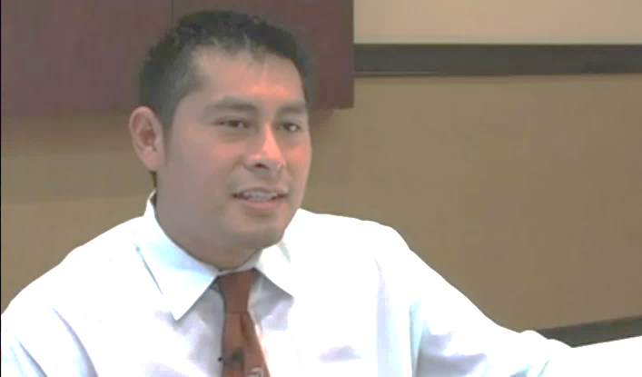
Resources Available
- Mentoring from experienced attorneys in most areas of civil law except immigration

Contacts
- Resource/Managing Attorney: Colleen Beebe
- Case Coordinator: Barb Cruz

Administrative | Ensure that individuals and their families are not deprived of their livelihood

Full representation services¹ NEED
- MDH and DHS Maltreatment, Neglect, or Abuse Determination Request for Reconsideration
- MDH and DHS Disqualification Requests for Reconsideration

Phone Services² NEED
- Legal advice and, when appropriate, brief legal services⁴ regarding all areas of admin law

Screening for Merit³ GREAT NEED
- Determining whether clients meet VLN criteria for full representation services

Mentor Attorney³ NEED
- Spend two to eight hours answering case-specific questions from an attorney new to the area of law.

Resources Available
- Forms & templates
- CLE materials
- Mentoring from experienced attorneys

Contacts
- Resource/Managing Attorney: Glen Drew
- Case Coordinator: Emily Tanner
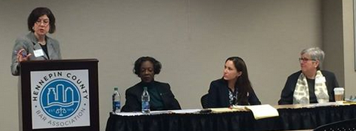
Employment & UC | Protect workers’ rights to be paid hours they’ve worked, to receive UC when they’ve been let go, and to be terminated lawfully.

Full representation services¹ LOW NEED
- Wrongful termination if client is seeking their job back
- Help recovering back pay up to $3,000
- Employee benefit issues
- Unemployment compensation (UC) when a worker has been let go

Phone services² LOW NEED
- Advice and, when appropriate, brief legal services⁴ regarding any employment law issue. Brief legal services might include writing wage demand letters or making phone calls to current or past employers, for example.
- Determining whether clients meet VLN criteria for full representation services

Mentor Attorney³ FILLED
- Spend two to eight hours answering case-specific questions from an attorney new to the area of law.

Resources Available
- Forms & templates
- Mentoring from experienced attorneys

Contacts
- Resource/Managing Attorney: Glen Drew
- Case Coordinator: Heidi Huber

Real Estate | Protect an individual’s home and, often, only significant asset.

Full representation services² FILLED
- Mortgage or lien issues  - Joint ownership of property  - Leasing with option to buy  - Easement questions | - Truth in housing  - Real estate fraud  - Equity stripping  - Contract for deed and cancellation of contract for deed

Phone services² NEED
- Advice and, when appropriate, brief legal services⁴ regarding real estate issues
- Determining whether clients meet VLN criteria for full representation

In Person Clinic Opportunities² NEED
- Advice and, when appropriate, brief legal services⁴ regarding real estate issues
  - Xxx, Minneapolis
  - Xxx, St. Paul

Screening for Merit³ FILLED
- Determining whether clients meet VLN criteria for full representation services

Mentor Attorney³ FILLED
- Spend two to eight hours answering case-specific questions from an attorney new to the area of law.

Resources Available
- Training materials
- Substantive and procedural resources
- Forms & templates
- Mentoring from experienced attorneys

Contacts
- Resource/Managing Attorney: Laura Busian
- Case Coordinator: TBD

Tax | Help individuals successfully navigate the complex regulations around Minnesota taxes and, when necessary, enter into manageable payment plans.

Full representation services¹ LOW NEED
- Disputes with the MN Department of Revenue
- Collections cases with the MN Department of Revenue

Phone Services² LOW NEED
- Legal advice and, when appropriate, brief legal services⁴ on any Minnesota Department of Revenue tax issue

Screening for Merit³ LOW NEED
- Determining whether clients meet VLN criteria for full representation services

Resources Available
- Forms & templates
- CLE materials
- Mentoring from experienced attorneys

Contacts
- Resource/Managing Attorney: Glen Drew
- Case Coordinator: Heidi Huber

Rule 6C. (Rules of the Board of Continuing Legal Education (special categories of credit): Pro Bono Legal Representation. A lawyer may claim 1 hour of standard CLE credit for every 6 hours of pro bono legal representation as defined by Rule 2U [means providing legal representation to a pro bono client without compensation, expectation of compensation, or other direct or indirect pecuniary gain] that the lawyer provides to a pro bono client as defined by Rule 2T [means an individual, who is not a corporation or other organizational entity, and who has been referred to the lawyer by an approved legal services provider or by a state or federal court program] in a legal matter that has been referred to the lawyer by an approved legal services provider as defined by Rule 2B or by a state court or federal court program. No more than 6 hours of credit may be claimed per reporting period by a lawyer for pro bono legal representation. In order to receive CLE credit the lawyer must submit an Affidavit of Pro Bono Representation to the Board (see Appendix II)
If a mentor attorney, ask the primary attorney to include your hours when completing the case closing form.

